GENERAL INSTRUCTIONS AND INFORMATION

- Omicron Delta Kappa initiation and installation ceremonies may be open to guests

  - Circles are encouraged to invite friends/family members, local O∆K lifetime/alumni members, and O∆K circles in the region
  - Circles are also encouraged to send invitations to chief institutional officers

- Members of the circle shall assemble at the appointed place, all wearing business attire or academic regalia

- This handbook provides alternative language for the start and conclusion of the initiation ceremony

- Reserve a large room that holds the expected number of guests and inductees for the initiation/installation ceremony and arrange the space to be as attractive as possible.

- A table of suitable size will serve as a focal point for the ceremony.
- Drape the table with an O∆K tablecloth, plain tablecloth, or sheet; if using a plain tablecloth, place an O∆K podium cloth at front [8] or on a free standing podium [1]
- Place the O∆K Key in the center of the table [2]
- Place five white long-stemmed candles on the back left corner [3] (electric candles are acceptable)
- Place the circle record book on the front right corner [4]
- Place pins and certificates on the front left corner [5] [6]
- Place a bowl or vase filled with flowers (white and/or blue) on the table [7] (the official flower of Omicron Delta Kappa is the blue delphinium)

- Chair placement: semi-circle or area where inductees may receive certificates and sign record book in comfortable fashion

- Candidates for induction shall assemble in an adjacent room prior to ceremony

- Upon direction of the Circle President or Presiding Officer, designated guides lead candidates into the room; as the procession approaches the draped table, installing/circle officers take their places directly behind it; inductees should take their seats

- Music or an electronic presentation may be a part of the ceremony

- Circle officers and faculty/staff members should have roles within the ceremony

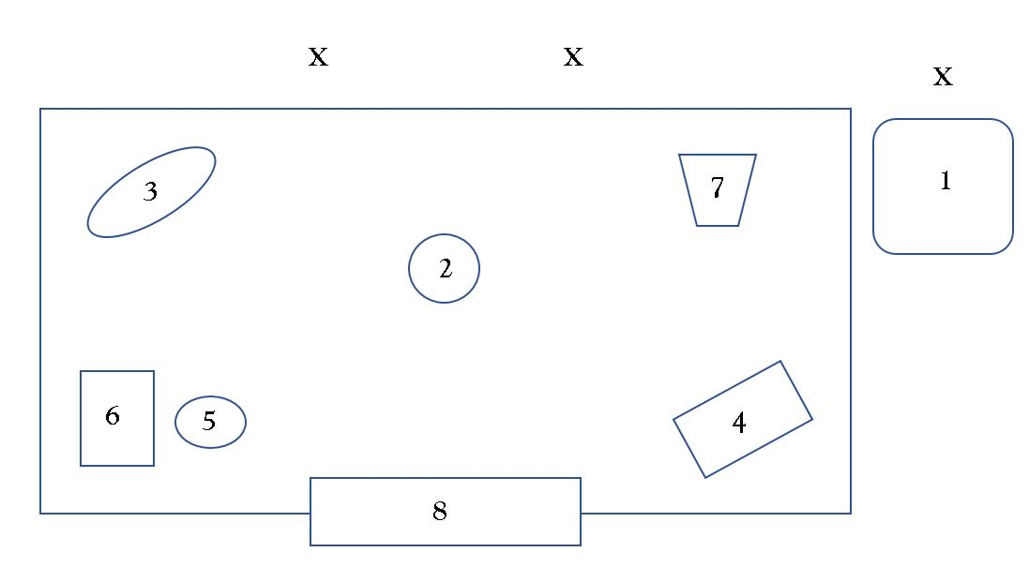
- The three “Voices” may speak from appropriate places at the initiation table or from the rear of the room or a balcony
- Circle may assemble for a banquet or special program following the ceremony

1. Free standing podium
2. O∆K Key
3. Five white long-stemmed candles
4. Record book
5. Pins
6. Certificates
7. Flowers
8. Podium cloth
x = Installation officer(s)

INSTALLATION/INITIATION CEREMONY
Introductions and Welcome
(Introductory comments and a general welcome may be given by the President/Presiding Officer or another individual as individuals gather for the start of the ceremony.)

President/Presiding Officer:
As the (President of the ____ Name of Institution ____Circle/____Presiding Officer’s Title) of Omicron Delta Kappa, I welcome you to this initiation/chartering ceremony held on your behalf. Those of us who are members of OΔK value its high ideals and purposes as we strive to provide leadership in worthy undertakings and to be of service to others. We believe in the tenets of this society and those principles for which it stands. We are pleased and honored to share them with you today as we welcome you into the newly chartered (if applicable) (________ Name of Institution) Circle of Omicron Delta Kappa.

Let us welcome (__________ Name of Individual) who will come forward to lead our invocation/opening moment of reflection.
(Circles should use the Invocation or Opening Moment of Reflection, but not both.)
Invocation: O God, we are grateful for the privilege of leadership in worthy undertakings and for the ideals of Omicron Delta Kappa. As we gather to confer the honor of membership upon these duly elected individuals, give to all assembled here a renewed vision of the meaning of Omicron Delta Kappa.
Grant that the desire for creative thinking, for high purposes and ideals, for moral strength and integrity may ever remain close to our hearts. Grant also that we may strive without ceasing to incorporate them into our lives as students, faculty, staff, alumni, and civic leaders. Instill in us, O God, the principles of faith and courage, of honest work, and of sacrifice for the tasks that lie before us. Amen.
Or
Opening Moment of Reflection: We are grateful for the privilege of leadership in worthy undertakings and for the ideals of Omicron Delta Kappa. As we gather to confer the honor of membership upon these duly elected individuals, give to all assembled here a renewed vision of the meaning of Omicron Delta Kappa. Grant that the desire for creative thinking, for high purposes and ideals, for moral strength and integrity may ever remain close to our hearts. Grant also that we may strive without ceasing to incorporate them into our lives as students, faculty, staff, alumni, and civic leaders. Instill in us the principles of faith and courage, of honest work, and of sacrifice for the tasks that lie before us.
HISTORY AND SYMBOLS
President/Presiding Officer: You have undertaken upon yourselves the obligation of membership in the Omicron Delta Kappa Society. This means that you will ever seek to make it a real factor for good in academic and community life, not only at your own college or university, but with American educational institutions at large and in the communities in which you will lead. As a member, you commit that you will make every effort to practice its high ideals, both in private and public life, so that the world may see in you a concrete, living symbol of the great principles of Omicron Delta Kappa.

Omicron Delta Kappa was founded on December 3rd, 1914, at Washington and Lee University, in Lexington, Virginia. Our 15 founders stated that leadership of exceptional quality and versatility in college should be recognized; that representatives of all pillars of college life should cooperate in worthwhile endeavor; and that outstanding students and faculty members should meet on a basis of common interest, understanding, and helpfulness.

The motives which guided the founders sprang from the desire to bring together one body for the general good of the institution, leaders from all parts of the college or university community. The success of the O∆K Idea, an essential part of which is its joint student-faculty character and a determination to maintain a consistent and high standard of leadership recognition, led to the establishment of chapters, which we call circles, at other colleges and universities.

The Society in which you are about to become a member has a three-pronged mission:
- Identify, honor, and develop leaders in collegiate and community life;
- Encourage collaboration among students, faculty, staff, and alumni to advance leadership; and
- Promote, publicize, and enhance our ideals.

The Society’s ideals are represented by our five leadership values:
(As each of the five leadership values are stated slowly and emphatically by the President/Presiding Officer, an assistant lights one candle at a time until all five candles are lit.)
- Collaboration – to work together to achieve a defined and common purpose
- Inclusivity – to actively seek, embrace, and advance a diverse group of individuals
- Integrity – to align one’s values and beliefs with behaviors and speech
- Scholarship – to strive for excellence in academics and to pursue lifelong learning
- Service – to answer the call for action from one’s community or country

It has ever been our desire and custom to try to symbolize in material form our dreams, ambitions, ideals, and sentiments. In accordance with this innate desire and feeling, Omicron Delta Kappa has also tried to express in material form, the "Key," its noble ideals, lofty aspirations, and altruistic aims. The key, which is struck in the form of a circle, symbolizes union forever and the equality which characterizes membership in Omicron Delta Kappa.

The Greek motto for which the letters O∆K stands is:
(Ho Daph-no'-ko-mos Kük'-los) which translates as "The Laurel Crowned Circle."

Our emblem, the Laurel Crowned Circle, stands for success achieved in worthy undertakings. The shape of the Key (the President/Presiding Officer points to a large replica of the Key) represents the circle, which symbolizes the all-around and inclusive nature of our organization. The five stars on the upper bar represent the five major pillars of college life, for which our Society stands:

- Academics and Research
- Athletics
- Service to Campus and Community
- Communications
- Creative and Performing Arts

The number 1914 on the lower bar indicates the year in which our Society was founded.

(At this point, the President/Presiding Officer may add a brief statement about the history or traditions of the local circle such as charter date, major circle programs, and distinguished members.)

INITIATION CEREMONY
President/Presiding Officer: We who are members of Omicron Delta Kappa have observed your habits, attitudes, and capacities, and are pleased with your success, your steady growth as leaders in worthwhile endeavors, and your appreciation of the ideals and purposes of the Society. We have asked you here today to make you members of our Society and to present to each of you the Laurel Crowned Circle, represented by the Key of Membership, the symbol of achievement. Before we accept you into the Omicron Delta Kappa Society, please listen thoughtfully to these words.
(The three voices may speak from appropriate places at the initiation table or from the rear of the room or balcony.)

First Voice: You should know that the Laurel Crowned Circle is not only a recognition of past exemplary conduct, but that it must also be to you a constant inspiration to finer and nobler living, so long as you shall live.

Second Voice: You should know that the Laurel Crowned Circle is not only a recognition of past loyalty to all good works, but that it must also be to you a constant inspiration to unselfish service to the Society, to (name of college or university) and to your vocation, and a life-long reminder that if greatness is to be achieved, one must serve.

Third Voice: You should know that the Laurel Crowned Circle is not only a recognition of past achievement, but that it must also be to you a constant inspiration to spend the rest of your days climbing higher and yet higher, ever remembering that death comes apace, and that the longest span of human life is all too short for the completion of the tasks that lie ready to our hands.

President/Presiding Officer: Will the candidates for membership please stand, if you are able? You have heard in these words the great unchanging principles upon which our Society is founded. If you are willing to accept the lofty ideals, the sense of devotion, and the spirit of aspiration represented in Omicron Delta Kappa, please respond, “I will.”

Candidates: I will.

President/Presiding Officer: Then please repeat after me.
"In the presence of the Circle here assembled,/
I solemnly promise/
to uphold the Ideals and Traditions,/
to follow the requirements of the National Bylaws,/
of the Omicron Delta Kappa Society,/
and to support in loyal service/
its local and national officers,/
to participate in its meetings, ceremonies, and initiatives,/
and to diligently foster/
life-long leadership."

You may be seated.

President/Presiding Officer: You have committed yourself to the principles of the Omicron Delta Kappa Society and to our timeless leadership values of collaboration, inclusivity, integrity, scholarship, and service. From this day forward and throughout each stage of your life, you will strive to serve as a living example of excellence in leadership.

You have been chosen to wear this emblem of distinction because of your loyalty and devotion to (______ Name of Institution) and to the things that are fine and true in life. Whenever possible, wear this pin with pride to demonstrate the honor bestowed upon you today. As your name is called, come forward to sign the Official Record of the (_____ Name of Circle) and receive the emblems of membership in our Society. (The President/Presiding Officer shall call each member forward by name and deliver to each one the symbols of membership in the Society.)

Insert the names of those being initiated.

Congratulations!

As newly inducted members of our Society, you have taken upon yourselves the obligations of membership. We hope you will take with you – and incorporate into your daily lives – the ideals of excellence in leadership and service that we have affirmed here today.
(Proceed to the Installation of Officers and/or Chartering Presentation if appropriate. If not, proceed to the conclusion of the ceremony on page 16 which includes the benediction/closing moment of reflection).

INSTALLATION OF OFFICERS

Presiding Officer (for newly chartered circles):
Congratulations and welcome to Omicron Delta Kappa Society as the members of our newest circle. The (__________ Name of Institution) Circle is one of approximately 300 active circles in the United States.

Outgoing President/Presiding Officer (for all circles): I now ask that the incoming officers of the (_______ Name of Institution) Circle of O∆K come forward to take the oath of office.

President: _________________________________
Vice President: _________________________________

Circle Coordinator: _________________________________
Faculty Advisor: _________________________________
Treasurer: _________________________________
(Additional officers may be sworn in if selected by the circle.)

Outgoing President/Presiding Officer: Please raise your right hand and repeat after me.

“I do solemnly promise/

That I will discharge the duties of my office/

In accordance with the local and National Bylaws/

To the best of my knowledge and abilities/

Bearing in mind always/

The welfare of my alma mater/

And of the Omicron Delta Kappa Society.”

Congratulations! We thank our outgoing officers for their work over the past year and welcome the new officers.

(The next page contains the Charter Presentation for newly established circles. To conclude the regular initiation ceremony, please see page 16.)

CHARTER PRESENTATION

Presiding Officer:

I would now like to invite the new officers and (_________ Names of Select Individuals) to remain here or come up front for the presentation of the circle’s charter.

On behalf of the Board of Trustees of Omicron Delta Kappa, the National Leadership Honor Society, it is my honor to present this charter officially recognizing the (_______Name of Institution) Circle of Omicron Delta Kappa as a full member of the Society with all of the rights and privileges granted there unto. The (_______Name of Institution or Nickname) Circle is the (circle number) chartered circle in the Society’s history.

This charter represents many hours of dedicated effort on the part of the students, faculty, and staff of (__________ Name of Institution). It is also a symbol of the college’s/university’s belief in the importance of recognizing and inspiring excellence in cooperative leadership endeavors on campus and throughout the greater community.

Congratulations! We are confident that O∆K will thrive here and help each of you as you continue in your leadership journeys.
CONCLUSION
(Before concluding the ceremony, circles are invited to sing “We’re Proud to be O∆K.” An audio file containing the musical accompaniment and sheet music are both available at odk.org.)

President/Presiding Officer:
To conclude the ceremony, please welcome (__________ Name of Individual) to conclude today’s ceremonies.
(Circles should use the Benediction or Closing Moment of Reflection, but not both.)

Benediction: Most gracious God, our eyes are open to all lovely objects of righteousness and truth, and we have been blessed with courage and enthusiasm, high impulse and lofty thought. In this, our hour of great dedication, help us as we go out into the world to keep fresh in our lives the ideals which wbe have affirmed here today. Amen.
Or
Closing Moment of Reflection: Our eyes are open to all lovely objects of righteousness and truth, courage and enthusiasm, high impulse, and lofty thought. In this, our hour of great dedication, let us go out into the world and keep fresh in our lives the ideals which we have affirmed here today.

